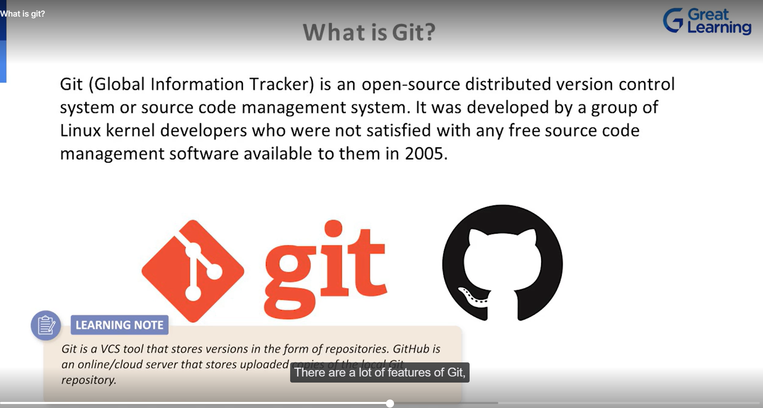

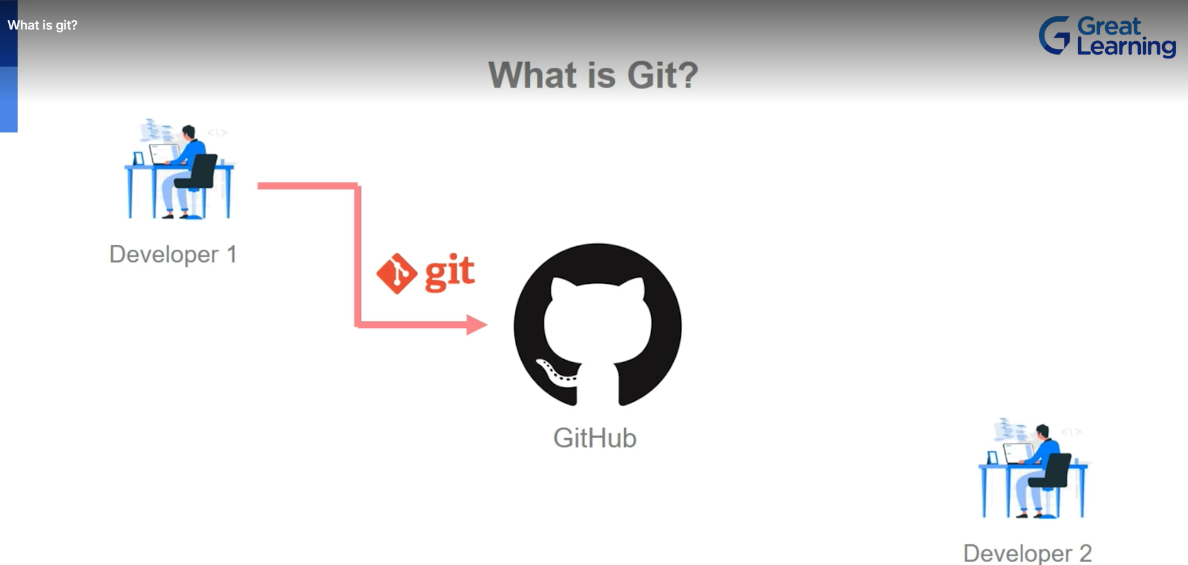

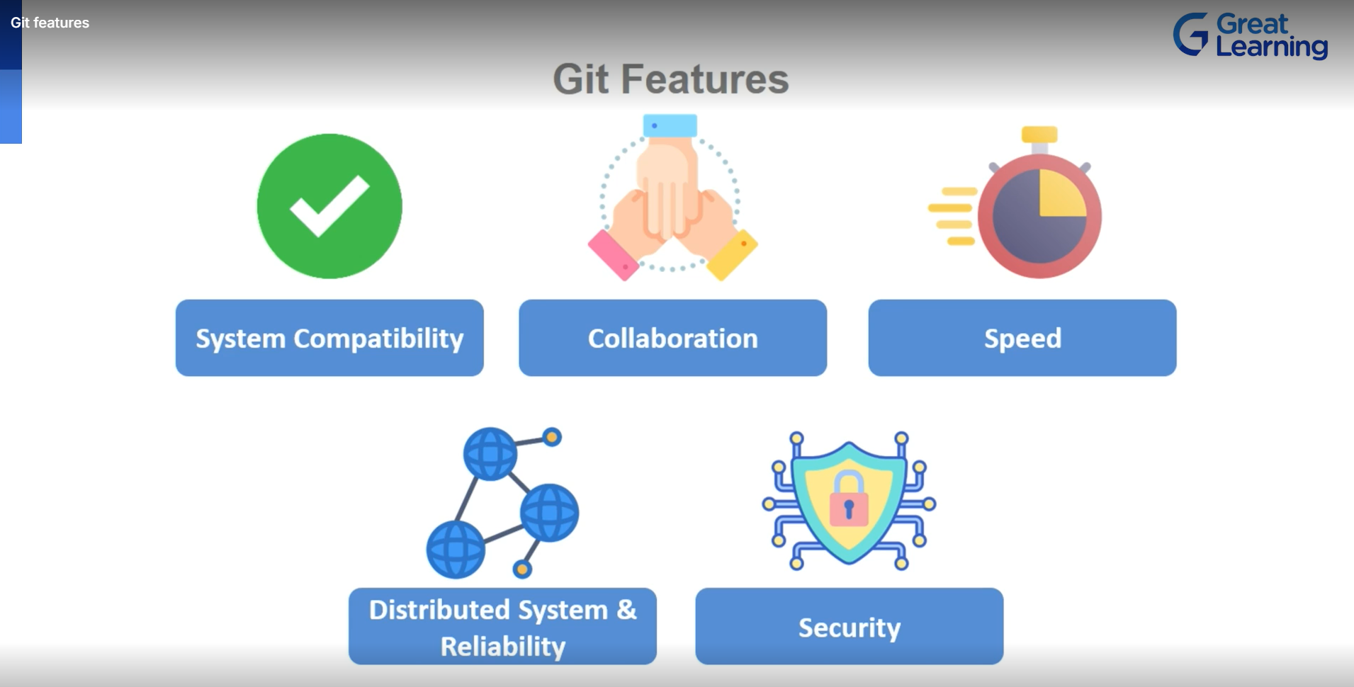

**Git Life Cycle:**

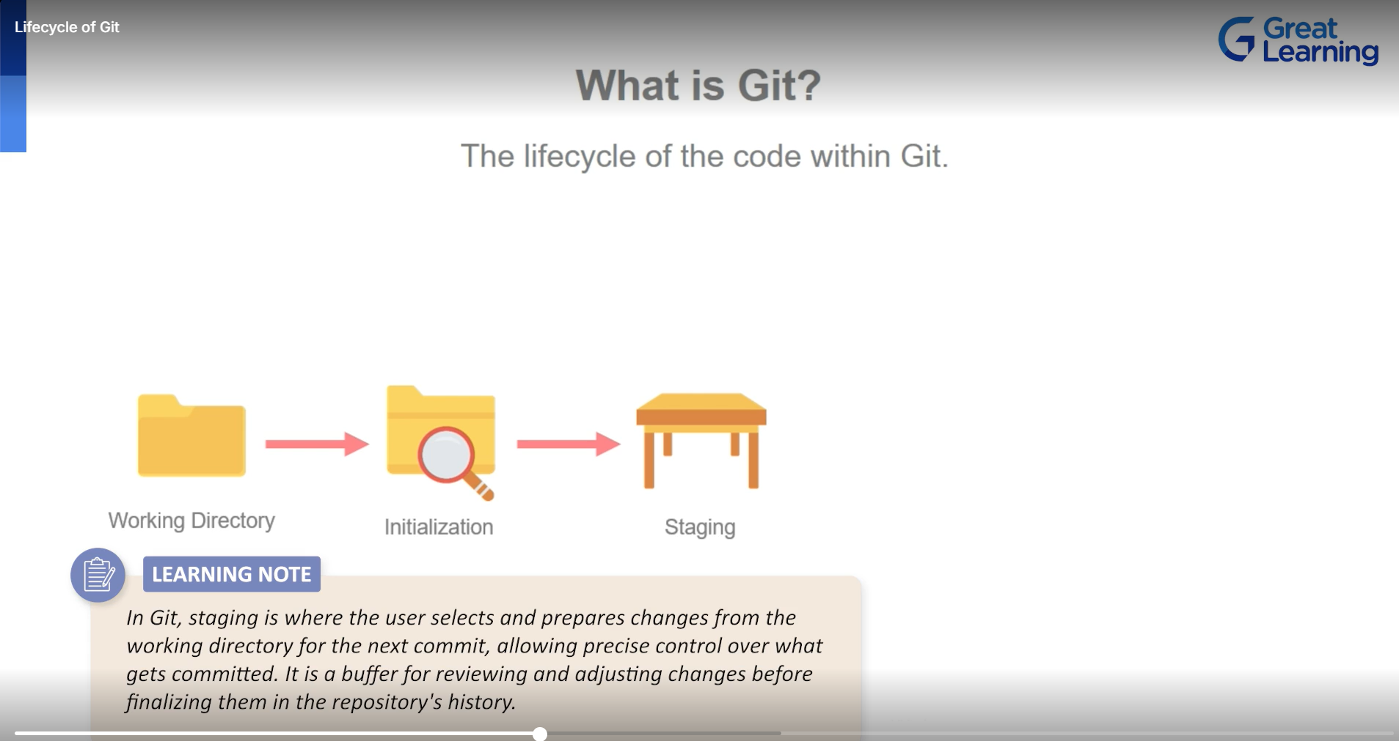

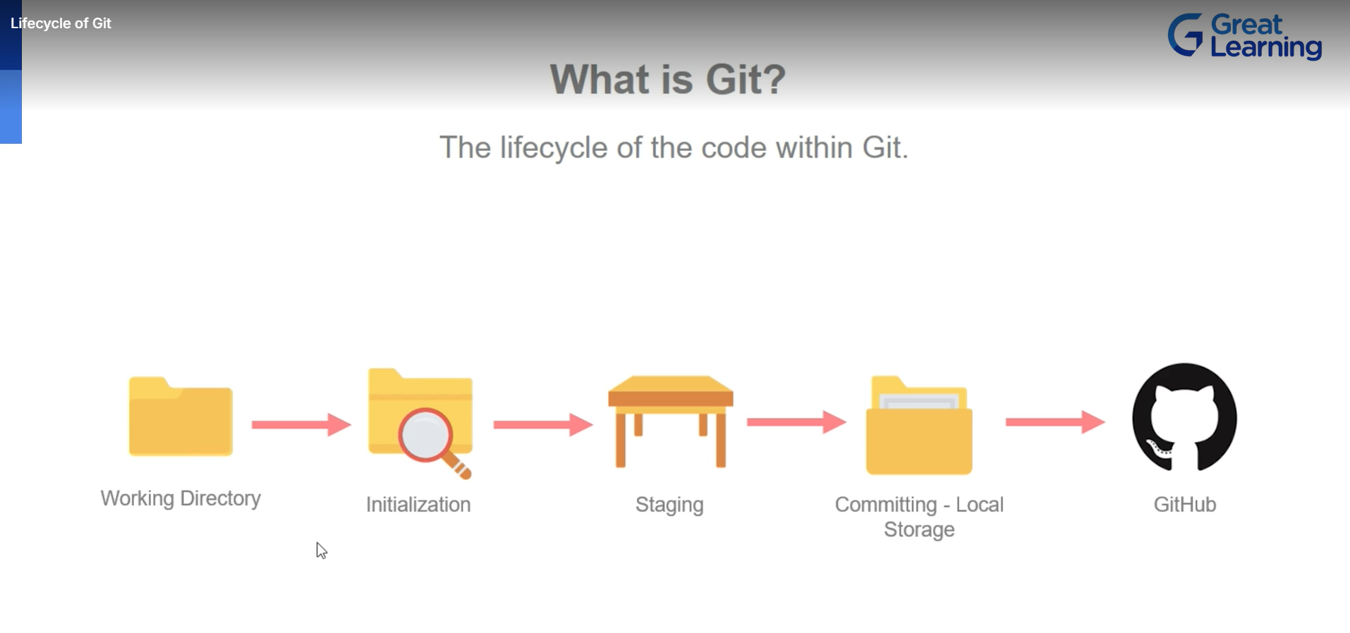

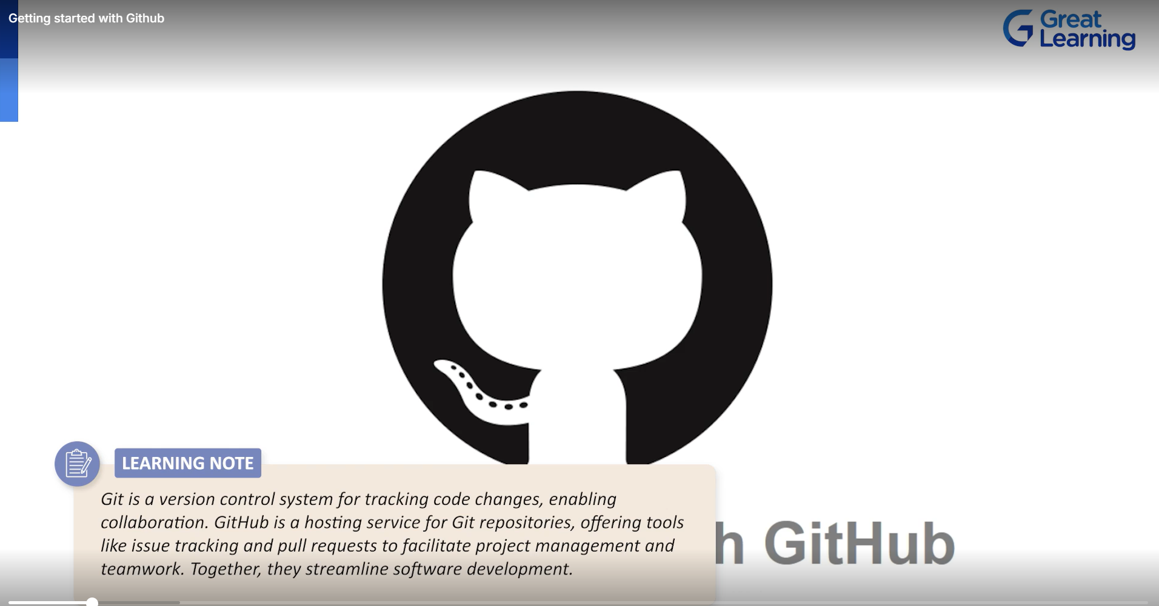

Git Hub :

It is a code repository

1.Start with creating Account here.



1. Create Repository :

REpository is the place where our code residdes.

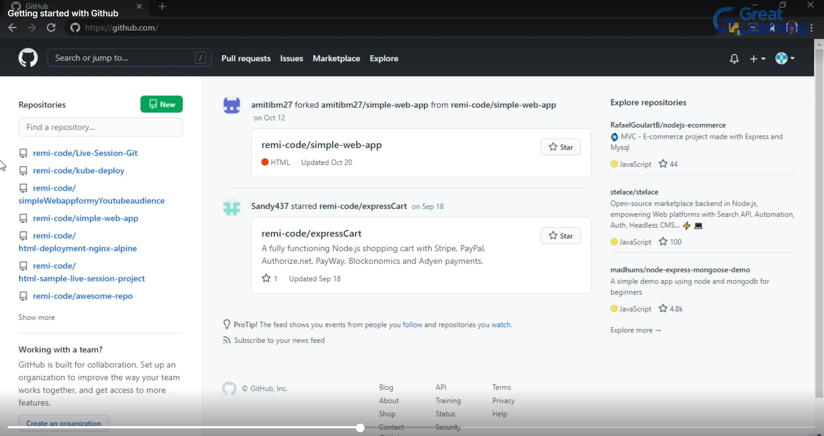

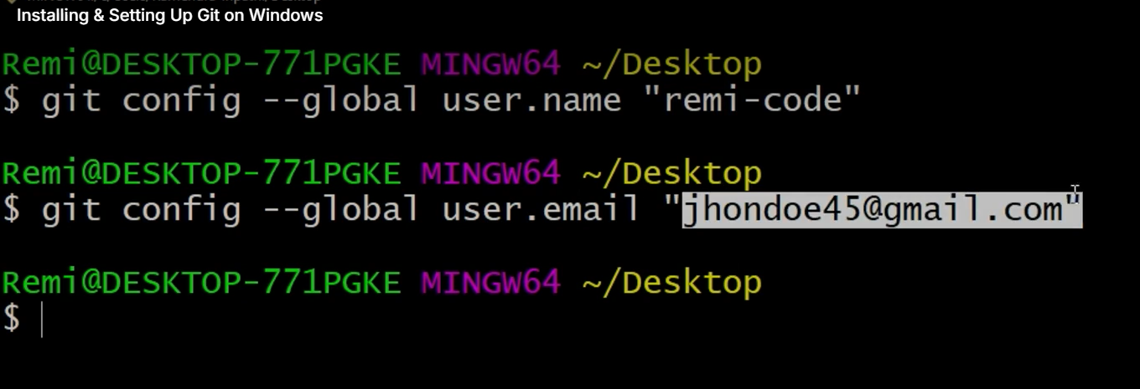

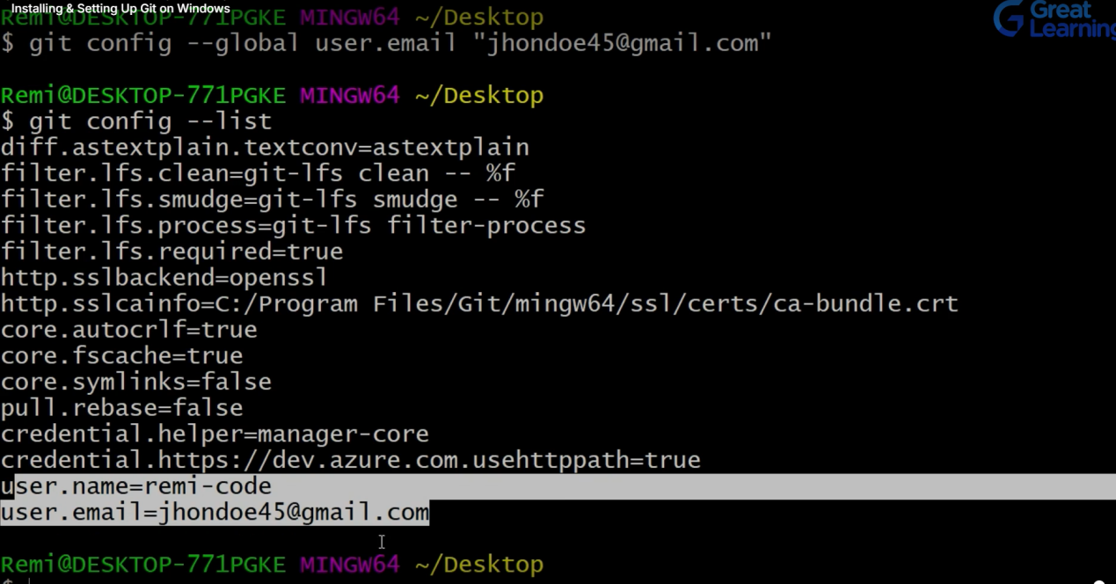

**git config --global user.name “Shishu123”**

**git config --global user.email “[shishupalkumar@gmail.com](mailto:shishupalkumar@gmail.com)”**

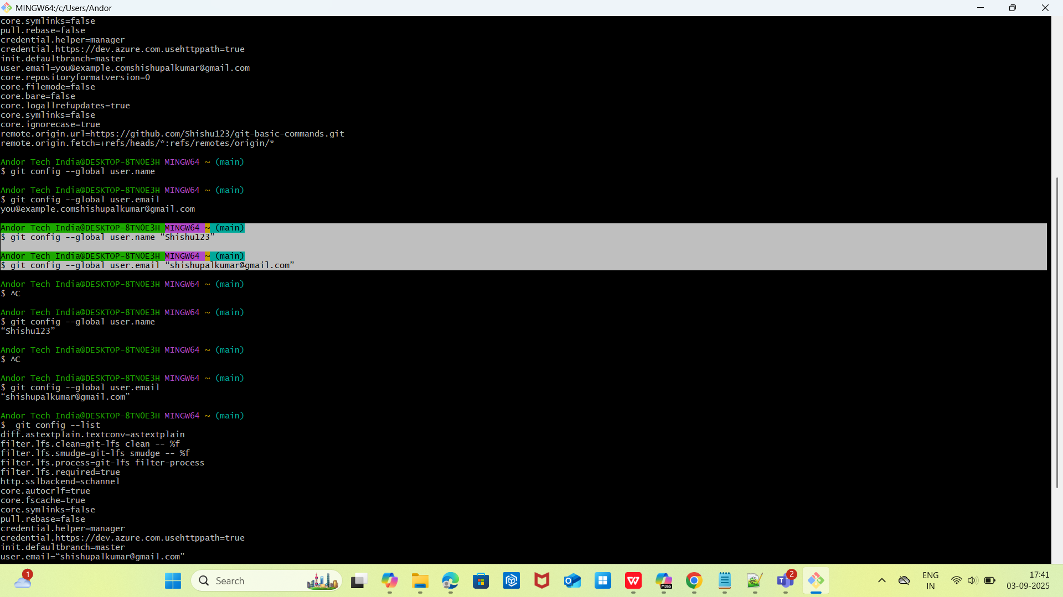

Ubantu Server : Use EC2 or Any Ubantu Server and inside that Install Git

Note: sudo => for Super User Access.

1. sudo apt update

Update all packages:  
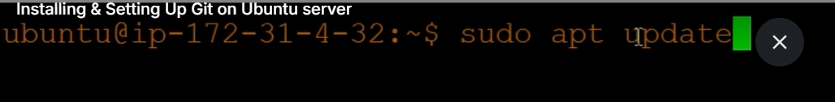

1. Sudo apt install git

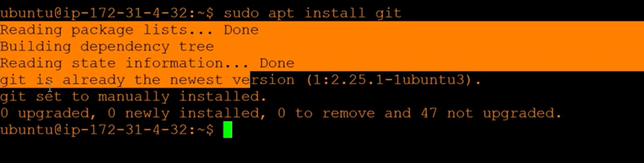

1. Configure git

**sudo git config --global user.name “Shishu123”**

**sudo git config --global user.email “[shishupalkumar@gmail.com](mailto:shishupalkumar@gmail.com)”**

**List config:**

**sudo git config --list**

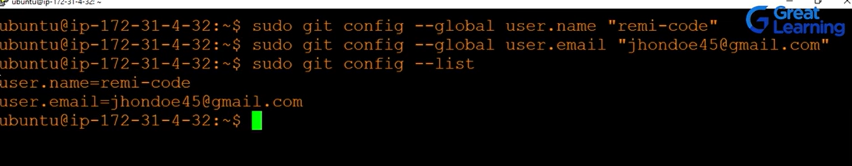

**GIT BASIC COMMANDS :**

Step1: Create a new Project Directory in Local drive

mkdir project

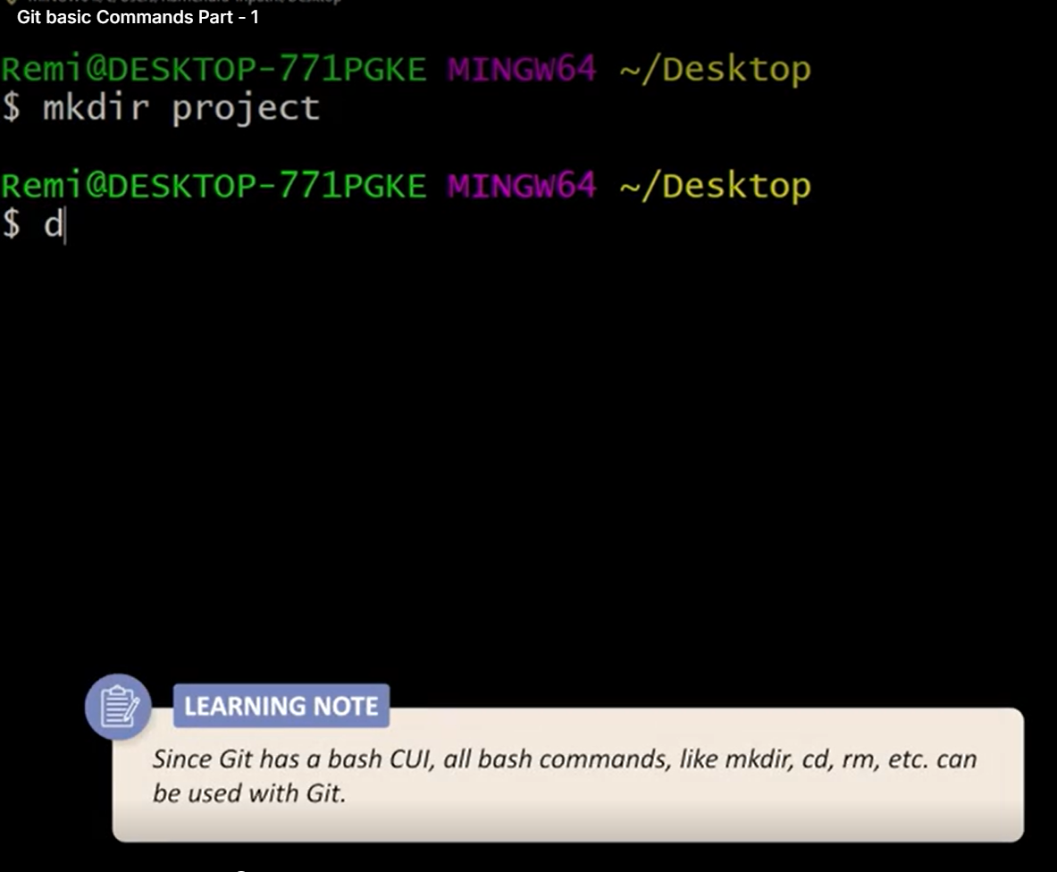

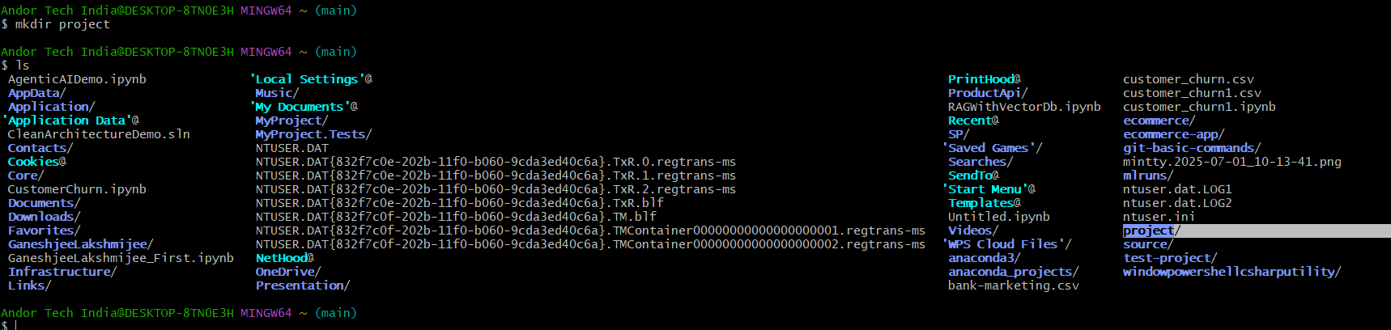

1. Change to working directory / folder

cd project

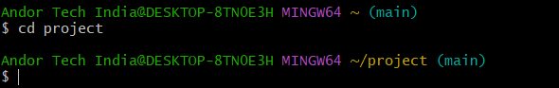

1. Initialize local directory as a repository:

git init

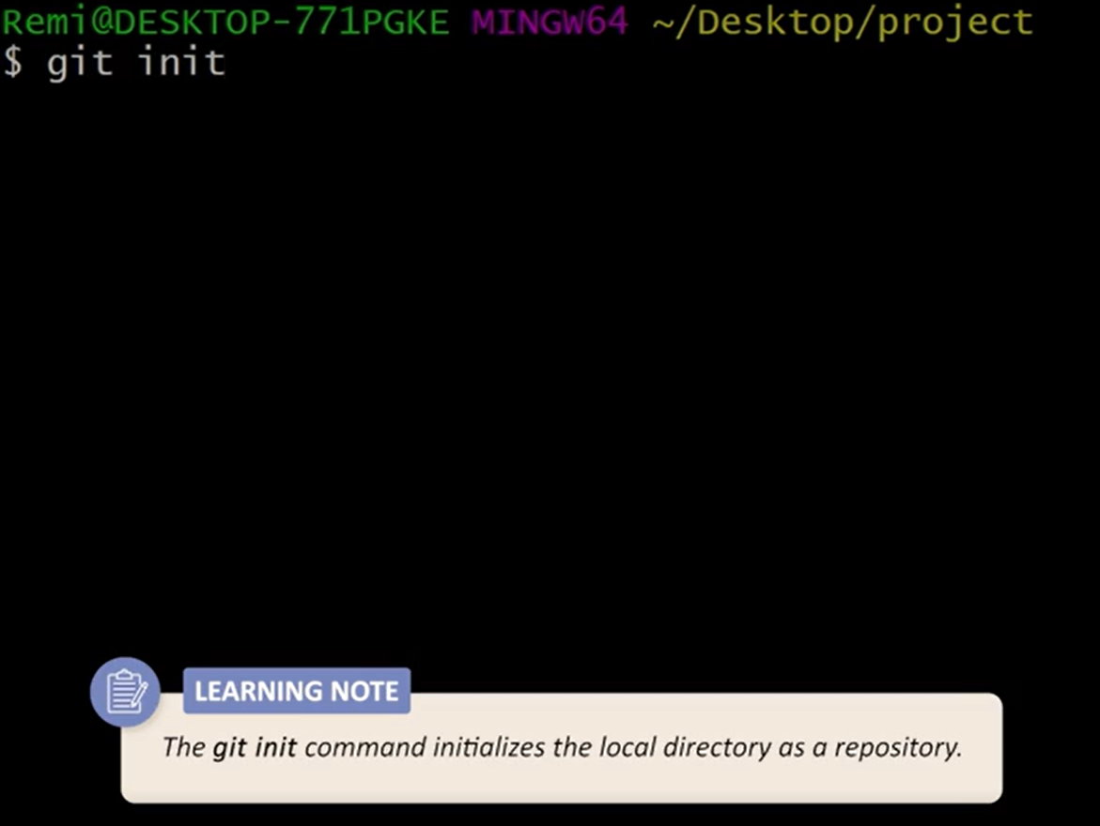

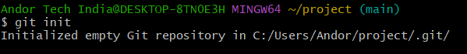

Note : (main) => main / master branch

1. Create a file using nano editor

Eg. Create an Index.html file => a Basic html file

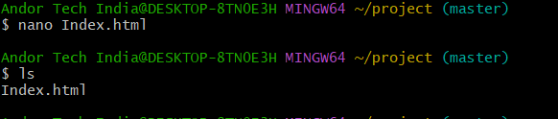

Ctrl+o then Enter

Ctrl+x =>Exit

1. Staging =>Marking of the file and its current version to go into

The commit snapshot:

git add .



This will staged all files in current / working directory/

Note :Check the status of the git

git status

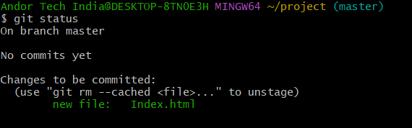

1. Commit changes

git commit -m “Added Index.html file”

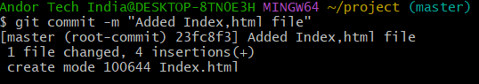

Note: git commit =>commit changes and save only stagged file of previos step.

So for committing stagging of files must be completed.

- chech status:

git status

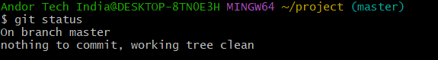

1. Push the code to Git Repository:

This is our git url :https://github.com/Shishu123/git-basic-commands.git

We have already commited code say Index.html to push this url.

We know this but git does not know this what chanes need to push inside the git.

So , we need to run this command:

Andor Tech India@DESKTOP-8TN0E3H MINGW64 ~/project (master)

$ git remote add origin https://github.com/Shishu123/git-basic-commands.git

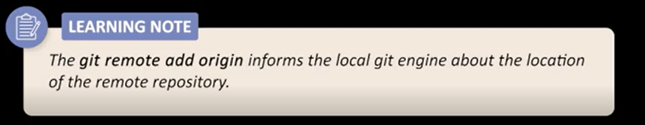

Note : we are adding git url as origin

Now we will push our file to this origin:

Andor Tech India@DESKTOP-8TN0E3H MINGW64 ~/project (master)

$ git push origin master

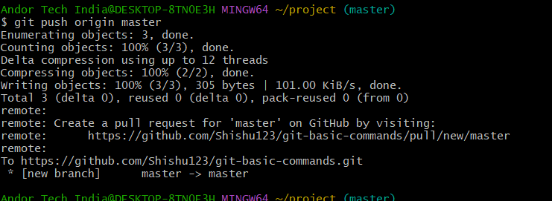

Note: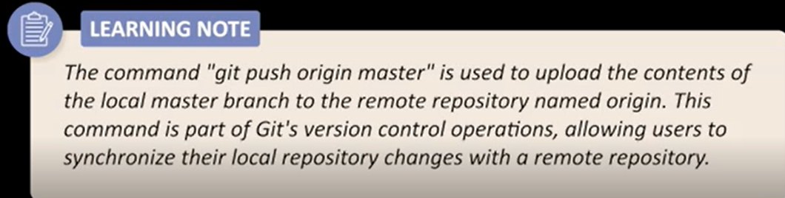

So here local branch master and its commint changes say in Index.html will pushed to the origin.

Origin => url or stands for remote location of the Git.

We can see this Index.html file in git now:

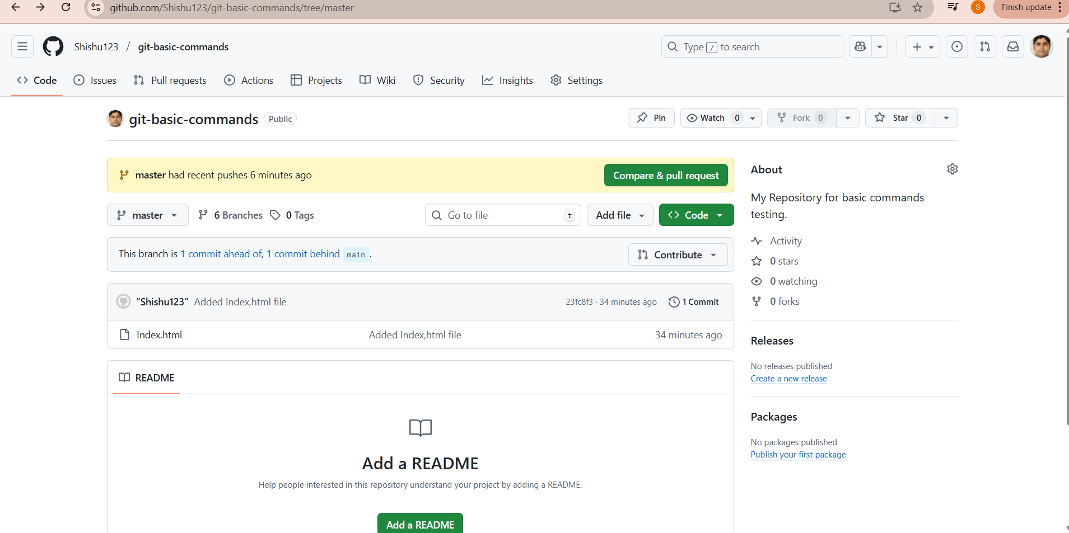

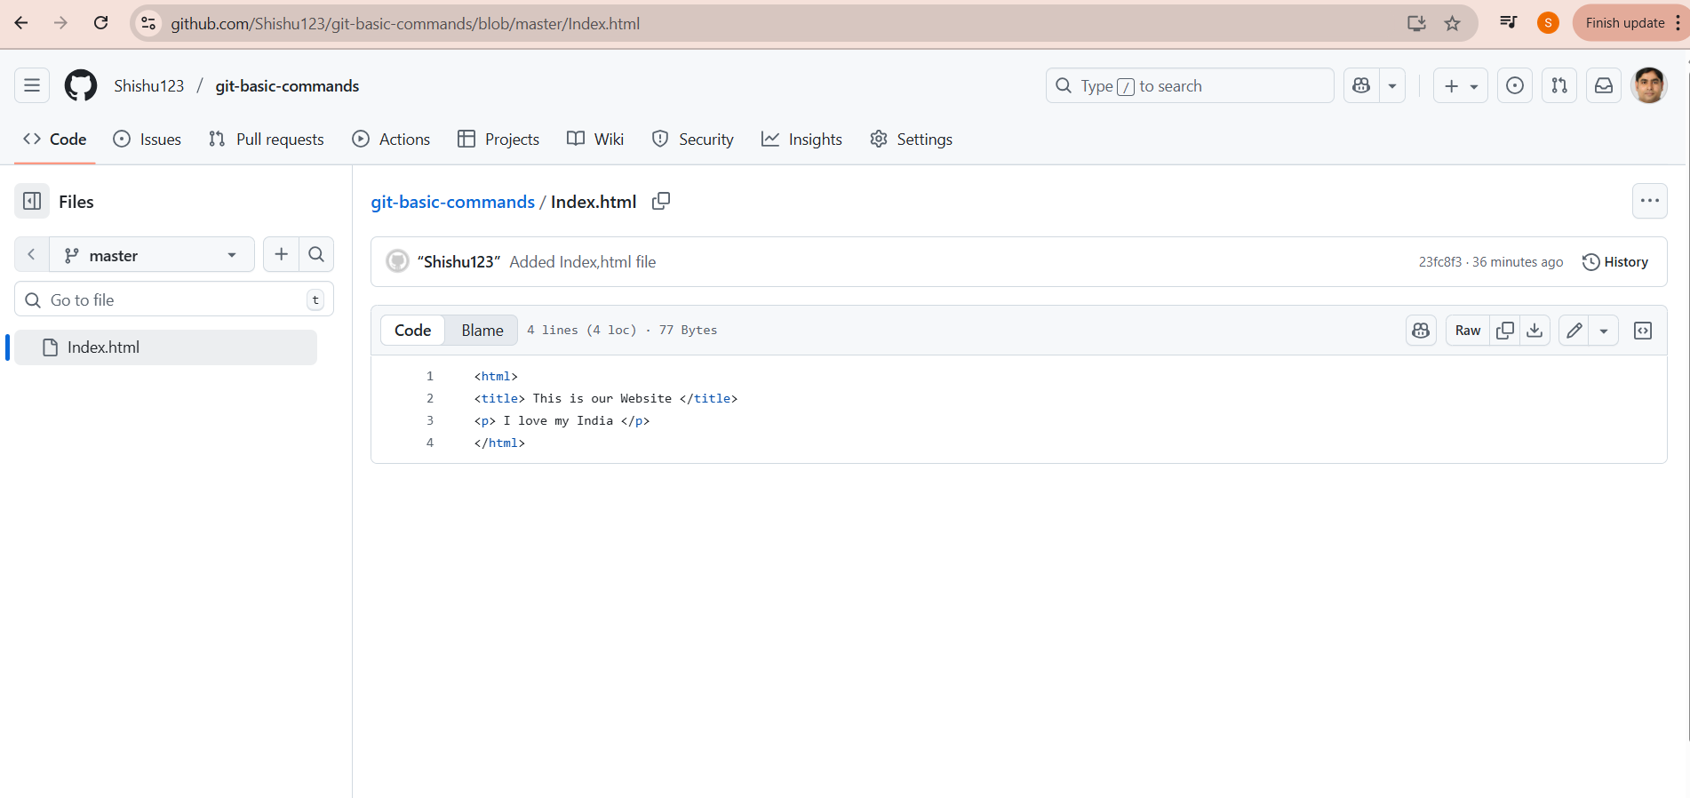

Important Points:

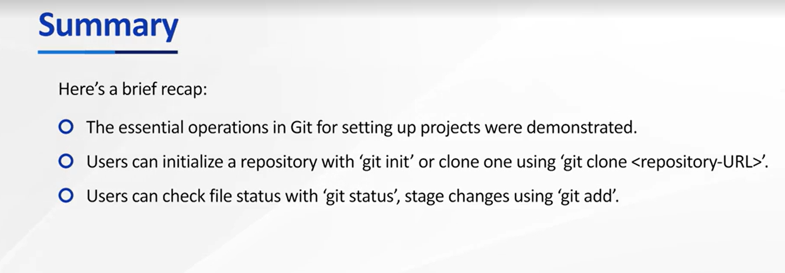

Now we will Change something in Index.html ->Stagged->coomit->Push to origin

Open Index.html file with nano command ->make changes like add h1 tag ->ctrl O for Save ->Enter->Ctrl+X for come out

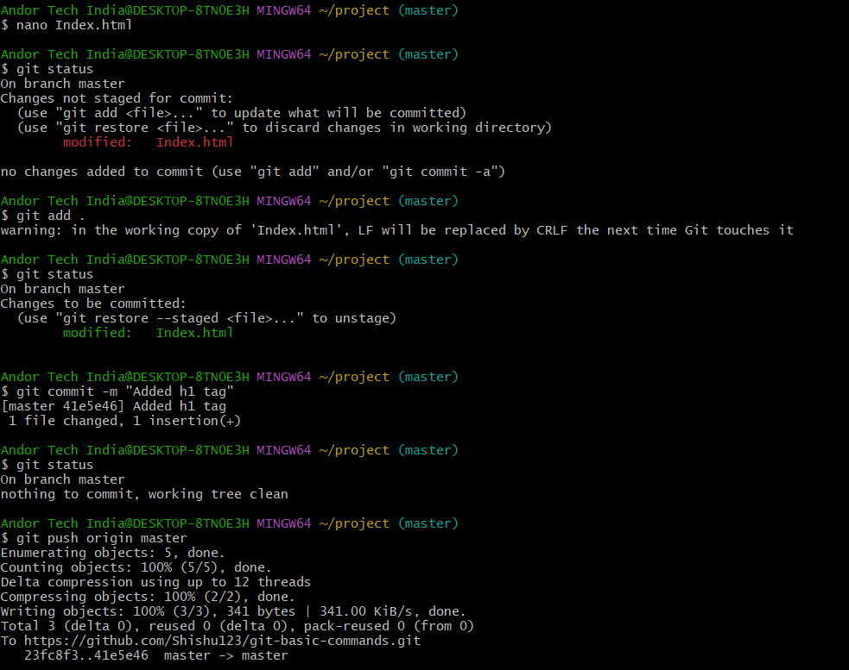

Note : Only 1 time Remote add is required if once done then no need we can directly use

:git push origin master

Example:

Andor Tech India@DESKTOP-8TN0E3H MINGW64 ~/project (master)

$ git push origin master

3rd changes:

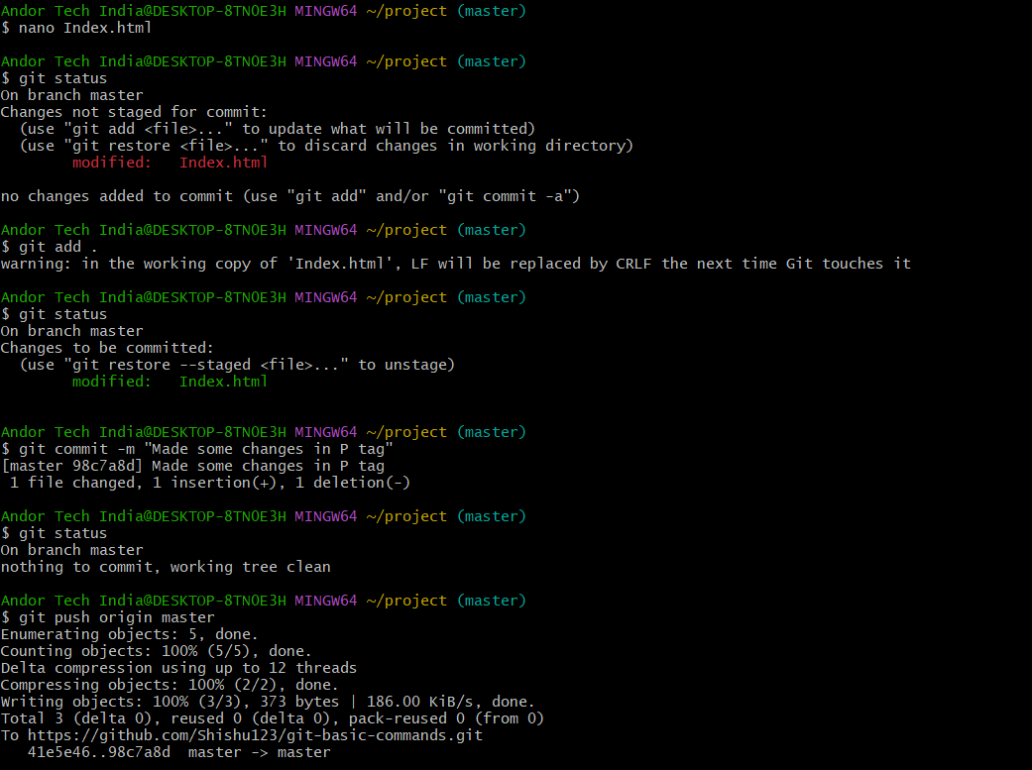

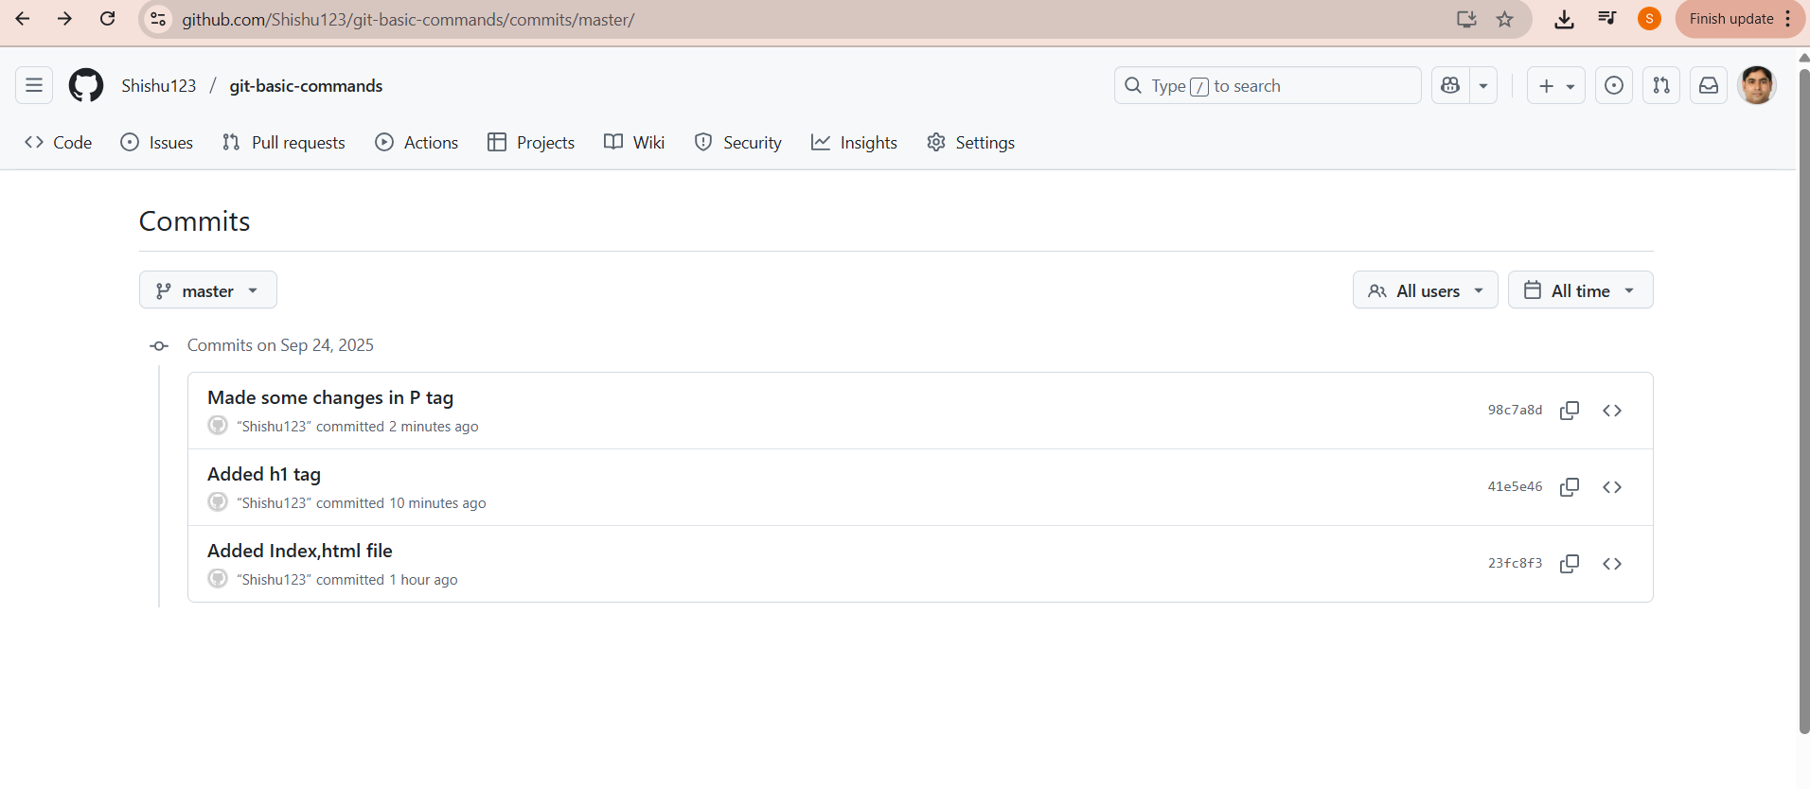

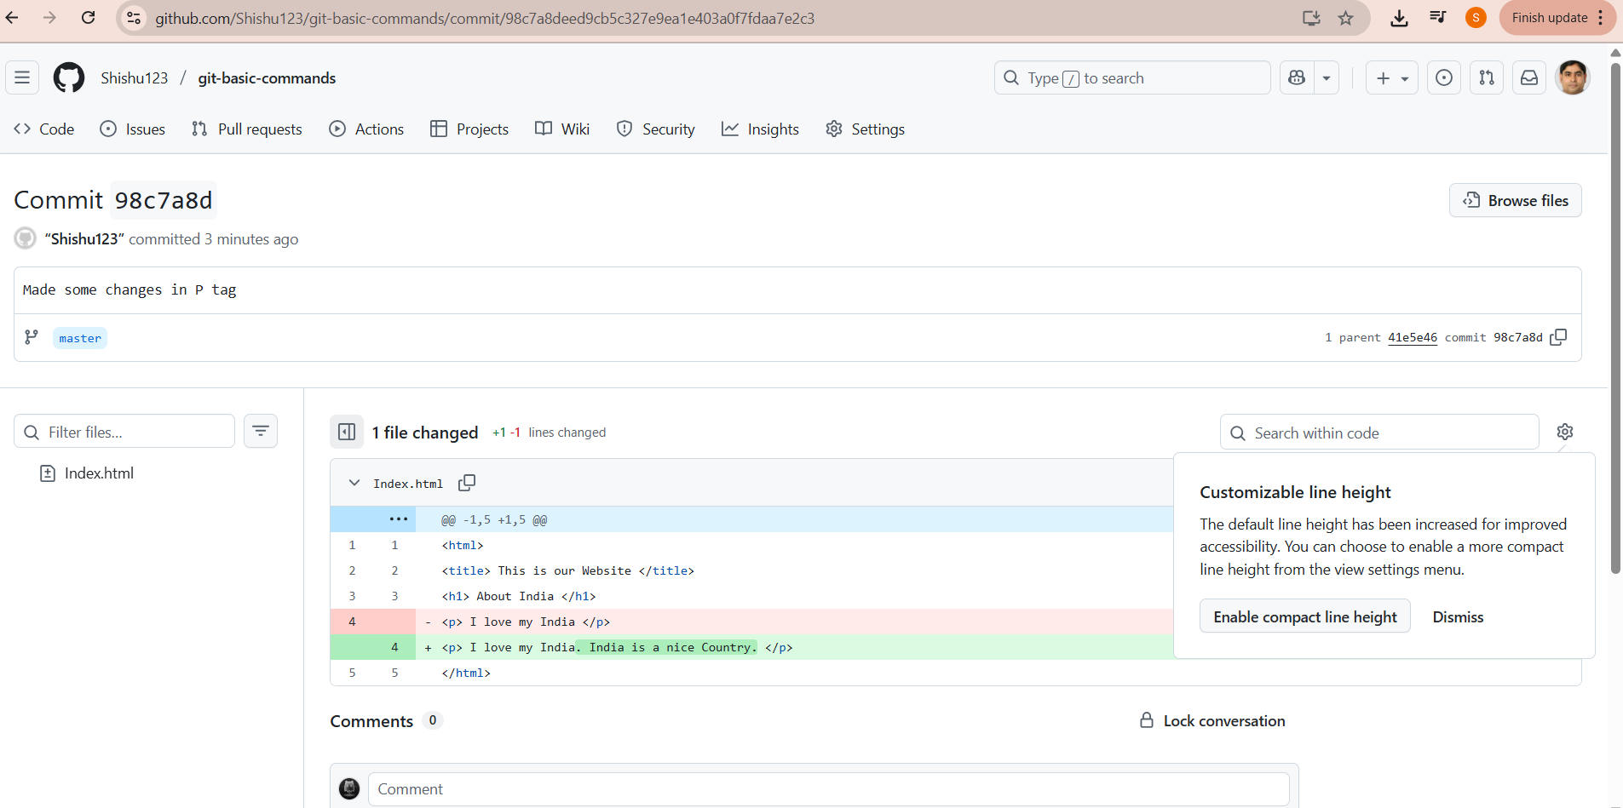

git log =>Tell all local commit commands

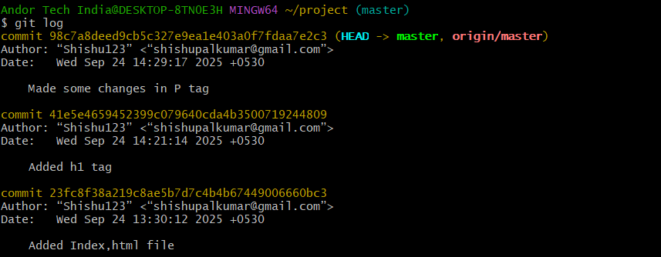

Here 3 commits with 3 commit Ids.

git revert command : It will revert to any git commited version with their commit Id.

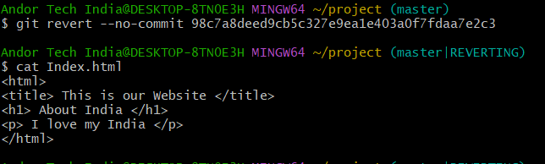

Case study:

Now Again added a New Files then Commnads Need to run :

1.Andor Tech India@DESKTOP-8TN0E3H MINGW64 ~/project (master|REVERTING)

$ git add .

Andor Tech India@DESKTOP-8TN0E3H MINGW64 ~/project (master|REVERTING)

$ git status

On branch master

You are currently reverting commit 98c7a8d.

(all conflicts fixed: run "git revert --continue")

(use "git revert --skip" to skip this patch)

(use "git revert --abort" to cancel the revert operation)

Changes to be committed:

(use "git restore --staged <file>..." to unstage)

new file: Git_Command_GreatLearning_3rdSept2025.docx

modified: Index.html

Andor Tech India@DESKTOP-8TN0E3H MINGW64 ~/project (master|REVERTING)

$ git commit -m "New File GitCommand Added"

[master fa989ea] New File GitCommand Added

2 files changed, 1 insertion(+), 1 deletion(-)

create mode 100644 Git_Command_GreatLearning_3rdSept2025.docx

Andor Tech India@DESKTOP-8TN0E3H MINGW64 ~/project (master)

$ git status

On branch master

nothing to commit, working tree clean

Andor Tech India@DESKTOP-8TN0E3H MINGW64 ~/project (master)

$ git push origin master

Enumerating objects: 6, done.

Counting objects: 100% (6/6), done.

Delta compression using up to 12 threads

Compressing objects: 100% (4/4), done.

Writing objects: 100% (4/4), 3.09 MiB | 1.46 MiB/s, done.

Total 4 (delta 1), reused 0 (delta 0), pack-reused 0 (from 0)

remote: Resolving deltas: 100% (1/1), completed with 1 local object.

To https://github.com/Shishu123/git-basic-commands.git

98c7a8d..fa989ea master -> master

Andor Tech India@DESKTOP-8TN0E3H MINGW64 ~/project (master)

$ git status

On branch master

nothing to commit, working tree clean

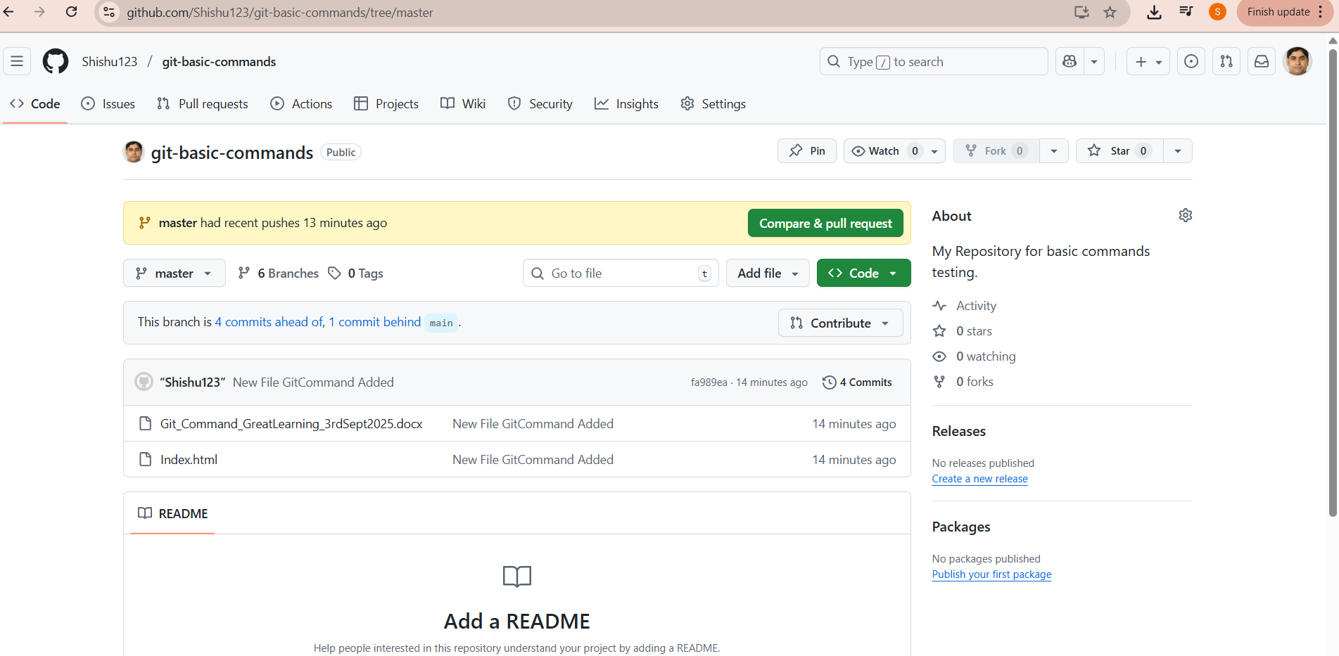

We can clone or download from git :

